1. 
2. Create an object for Thread class which is in **java.lang package**.
3. Its constructor is overloaded. Most commonly used which takes Runnable object.
4. Runnable object represents a task that is runnable in a thread. It has single method called run();
5. 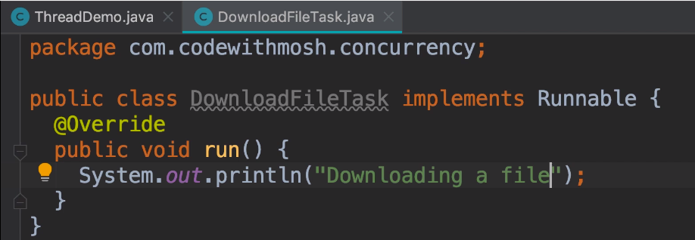
6. 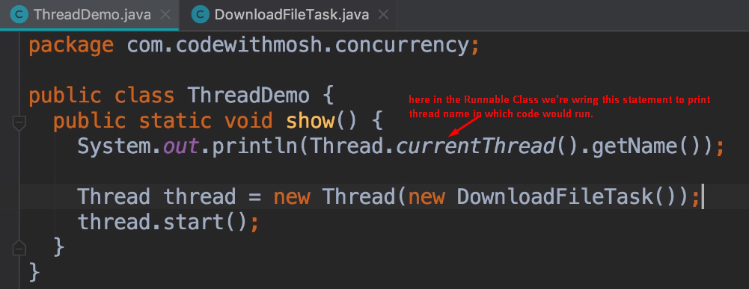
7. 